IOT BASED MINING INDUSTRY SMART HELMET FOR INSPECTING AND REPORTING HAZARDOUS EVENT DETECTION FOR MINING INDUSTRY

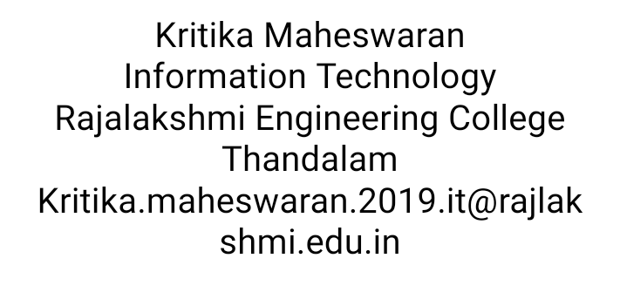

Keerthana G  
Information Technology  
Rajalakshmi Engineering College Thandalam   
[Keerthana.g.2019.it@rajalakshmi.edu.in](mailto:Keerthana.g.2019.it@rajalakshmi.edu.in)



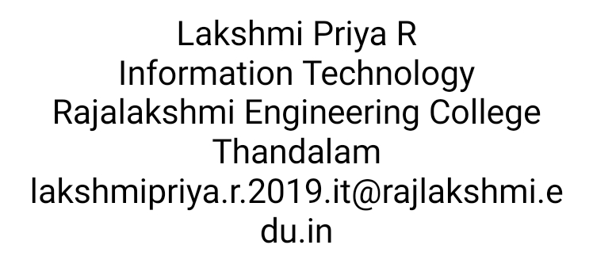

***Abstract*: A traditional smart helmet design that can recognize dangerous situations in the mining sector is being developed. Air quality, helmet removal, and collisions are three of the main types of hazards that were taken into account when developing the helmet. The first is the level of dangerous gas concentrations,** **such as particle matter, CO, SO2, and NO2.A miner taking off their mining helmet was considered the second hazardous event. The miner's helmet's position is successfully ascertained using an IR sensor after that. The third dangerous event is one in which a forceful object strikes a miner directly in the head.** **The head's acceleration and the HIC were calculated using software and an accelerometer. Tests are successfully done to calibrate the accelerometer. The experimental prototype consists of sensors namely gas, infrared, MEMS, GPS and pressure sensor for their usage and the sensor data are monitored in pc via Wifi transceiver unit.**

***Keywords*: IR Sensor, GPS, MEMS, Air Sensor**

1. Introduction

In recent years, Safety has long been a top priority in the mining sector, particularly in sub-surface mining. Mining accidents happen when minerals or metals are being extracted. Each year, mining accidents claim the lives of thousands of miners, particularly those engaged in hard rock and coal mining. One of the major factors in the majority of these accidents is the collapse of mining slopes. Most mining slope collapses do not result in fatalities. The injured miners can be helped with immediate first aid. However, in the shadowy depths of an underground mine, it is difficult to tell when a specific miner is in trouble. Consequently, there is a need for a system to track each miner's health in these situations.

mines. The safety helmet is one item that every miner wears. Therefore, in this situation, the helmet can be used to monitor the user's health and assist in relaying information outside the mines to the central office. The project uses the internet of things to try to accomplish the same thing. Each helmet worn by the miners has a sensor device. This sensing unit is linked to a force sensor, which determines whether the miner is bearing an unsafe load on his head. The miner may be in danger and may require immediate care if the load is too heavy. The motes therefore make an effort to get in touch with the fixed Room Manager mote, which is connected to both the Center and the nearby Room Manager motes. The Corresponding Room Manager of the distressed area tries to notify the Center of the occurrence of such an accident. Additionally, it requests that miners in nearby rooms or sectors voluntarily locate and aid the miner who is in danger. The Center can send a team to assist a specific miner as soon as they learn of their situation. The room may be deemed dangerous and the Center may activate the room's siren if there are more troubled miners present. Informing the miner in the adjacent room to stay out of that room is possible. It can lessen the number of casualties in this way. Another novel idea is to declare a certain area dangerous and to offer immediate assistance.

# EXISTING SYSTEM AND ISSUES

Accidents at mining and construction sites are frequently covered in the news. In this scientific era, mining and construction both provide housing for a large number of people. These include the start of the fire, the spread of dangerous gases, etc. These accidents are fatal; they shouldn't be taken lightly. The wearing of protective helmets at such locations is now required. However, while these helmets can shield the head from hitting objects, they are powerless to stop fires and other similar accidents. The lives of those who work at those sites are gravely in danger in this situation. Most contractors and employees exercise proper caution while working at these locations. However, there are still instances where people's lives are at risk. This is a query that demands an answer. We require a technological breakthrough that makes it possible for people to feel secure at these locations in this advanced technological age. Without making additional efforts, an accident can be reported to the public using technology that can detect gaseous leaks, environmental temperature changes, and worker heartbeats. Through the use of this technology, accidents would be prevented and lives would be saved. Therefore, preventing the spread of a fire or a gas leak that is harmful to the environment is crucial to saving the lives of the employees who depend on the area for their livelihood. In this case, technology is being used to save lives, which is a crucial application of technology.

1. PROPOSED SYSTEM

The system offers base station-based real-time mine monitoring. On the worker's helmet is the transmitter unit, and the base station is the receiver unit. IOT wireless technology is used to transmit data from the coal miners to the base station. The WiFi communication network offers two-way communication channels between base stations and mines as well as between base stations and mines. The transmitter unit is made up of an air quality sensor, a sensor for when a helmet is removed, and a sensor for when a person falls. If any abnormal activity is detected, the gps location will be sent to an IoT web server.

1. LITERATURE SURVEY

1. Shishir and et al. [2] have suggested a safety helmet for miners based on ZigBee wireless technology; in this instance, they are monitoring the environment's temperature, humidity, and gas concentration. The control center receives the detected data wirelessly using ZigBee When the sensed data differs from expected values, an alert is sent via ZigBee by turning on various LEDs and sounding an alarm. This system's limitation to real-time data viewing, the lack of a data logging mechanism, and inability to pinpoint which miner is having issues make it problematic.

2. Cheng Quing and et al. [1] based on ZigBee wireless communication, has proposed an intelligent helmet for coal mines. Their primary goal is to measure the mine's temperature, methane concentration, and humidity level. The base station will receive this detected data wirelessly using ZigBee. Voice communication is used by the ground station monitor to alert the miner to an occurrence. Since the miner will be operating in a noisy environment, this implementation has a problem, it is impractical to alert him via voice communication, so someone must be assigned to the monitoring room to keep an eye on the mines and issue alerts.

1. SYSTEM OVERVIEW

All of the said problems in the existing system can be solved by using IoT technology. Let us first understand what and how these methodologies work.

## BLOCK DIAGRAM

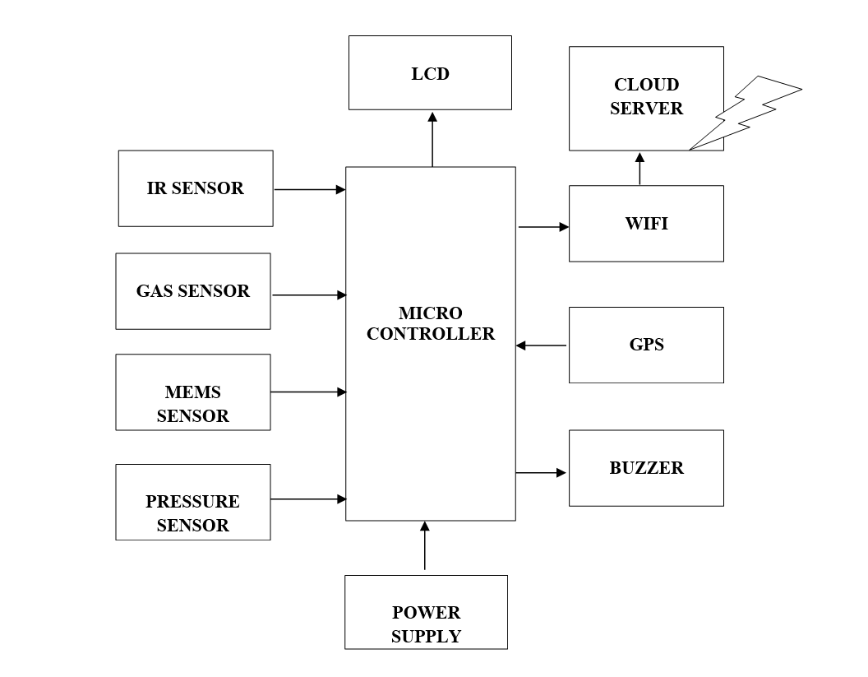

**Figure 2:** Block Diagram

## METHODOLOGIES

## Helmet Module

## GPS Module

5. HELMET MODULE

The latest safety technology is now in the helmet, which is frequently the sole piece of protective gear worn by miners. We made use of an accelerometer, an IR sensor, and an air quality sensor. These were used to check for head bumps, evaluate the air quality, and determine whether a miner had removed his helmet. A ZigBee module was linked to the three sensors. Operating system access is available for this module. maintains wireless communication between several helmets, does all processing (OS). The entire system was examined during the design process to reduce power consumption because the device is battery-powered. In order to keep the power level as low as possible, various sensors were considered for each individual component. The system will be disassembled into its component parts in order to clarify each part's function as well as the accessible substitutes. The system is made up of six parts: an alerting unit, a data processing unit, a wireless transmission, a sensor that detects when a helmet is removed, a sensor that detects collisions, a sensor that detects air quality, and a sensor that detects air quality.

**AIR QUALITY SENSOR**

Particulate particles and gases such as carbon monoxide (CO), methane (CH4), sulphur dioxide (SO2), and nitrogen oxides (NO2), are the main causes of air pollution from coal mines (CO). It is well known from numerous studies that exposure to these chemicals or pollutants by people can have a negative impact as to their health. These uneven ratios of gases that cause air pollution, including suspended particulate matter, rise cardiovascular issues and respiratory conditions like asthma and chronic bronchitis. [13].

**HELMET REMOVAL SENSOR**

A helmet removal technique based on an infrared ray sensor is used to determine whether or not a mine worker has taken off his protective helmet. An infrared sensor is set up to continuously deliver a signal from one end; if the signal is blocked, the miner is wearing a helmet; otherwise, he is not.

Switch found that among other ways, IR beam-based helmet-removal sensor technology was superior to analogue distance sensor and digital distance sensor. It is possible to create an IR beam that consumes little power. For this application, an IR distance detector that is readily available was used. A steady signal was supposed to be sent from one side of the helmet to the other by the IR sensor.

**COLLISION SENSOR**

A pressure using a sensor determine the severity of an object strike to a miner's head. According to the criteria for brain and neck injury, pressure is nothing more than force applied to an object per unit area. A moderate head injury is caused by pressure of 25 psi (pounds per square inch), while a severe head injury is caused by pressure of 34 psi.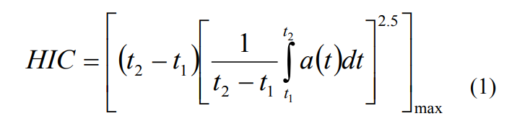

The equation is limited to impacts rather than continuous accelerations using the time constraint. It is also suggested that scull deformation may result in inaccurate accelerometer measurements. As a type of overdesign and compensation, Instead than being attached to the plastic strap that holds the head in place, the accelerometer is mounted directly to the helmet. This will enable the accelerometer in the helmet to achieve acceleration. that is higher than the miner's head's actual acceleration.

**RASPBERRY PI 4**

The third-generation Raspberry Pi is the Raspberry Pi 4 Model B. The powerful single board computer, the size of a credit card, will replace the Raspberry Pi 4 Model B and the Raspberry Pi original Model B+. The Raspberry Pi 4 Model B keeps the popular board format while giving you a more powerful processor that is ten times faster than the Raspberry Pi of the first generation. It is the ideal option for reliable linked designs because Additionally, it features Bluetooth and wireless LAN connectivity.

**FEATURES**

* A 64-bit, quad-core, 2.4 GHz ARMv8 CPU
* IEEE 802.11 Wireless LAN Connectivity
* Bluetooth 5.0
* Bluetooth Low Energy (BLE)
* 4GB RAM
* 40 GPIO pins
* Ethernet port

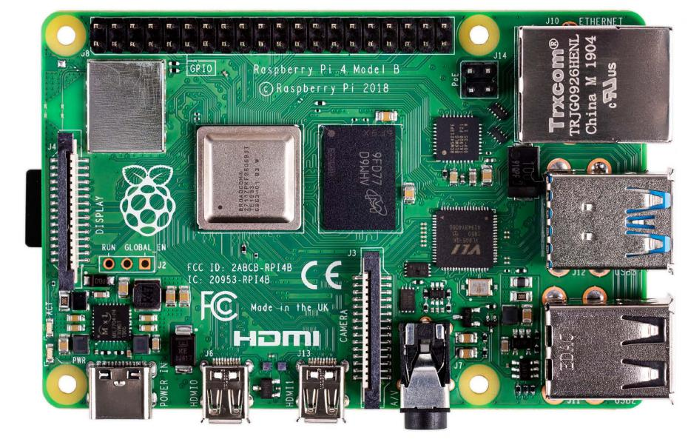

**RASPBERRY PI**

**BROADCOM BCM 2711 PROCESSOR**

The first-generation Raspberry Pi's Broadcom BCM2711 SoC (System of a Chip), which has a 700 MHz ARM 7.The Core processor, Video Core IV graphics processing unit (GPU), and RAM are similar to the technology used in first-generation smart phones (its CPU is an older ARMv6 architecture). The Raspberry Pi is a line of diminutive single-board computers created in the UK for use in classrooms and in underdeveloped nations by the Raspberry Pi Foundation. The initial model was promoted outside of its intended market for uses like robotics and used far more frequently than anticipated.. Keyboards, mouse, and cases are not provided with the Raspberry Pi as peripherals. However, a few official and unauthorized bundles contain some add-ons.

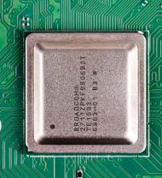

**BATTERY**

A battery is made up of one or more cells, and each of these cells undergoes chemical reactions that result in the flow of electrons in a circuit. The three components are an electrolyte, an anode (the "−" side), and a cathode essential components of every battery .

A chemical reaction happens between the anode and the electrolyte when a battery's cathode and anode are connected to a circuit. Electrons then return to the cathode and go through a second chemical change as a result of this process. The battery is unable to generate power when the cathode or anode material is depleted or becomes ineffective during the operation. Thus, battery is regarded as "dead."

**GAS SENSOR**

Oxygen depletion and combustible, flammable, and toxic gases can all be detected using gas detectors. This kind of instrument is commonly used in industry and is found in places like oil rigs to monitor manufacturing processes and cutting-edge technologies like photovoltaics. They could be employed in fighting fires. In the context of modern technology, monitoring the gases produced is crucial. Monitoring of gases is very important for everything from home appliances like air conditioners to electric chimneys and safety systems in industries. Gas sensors respond impulsively to the gas in the environment, informing the system of any changes in the concentration of molecules in the gaseous state. The sensing element is housed beneath a steel exoskeleton that makes up the gas sensor module.

Through connecting leads, current is applied to this sensing element. The gases that are near the sensing element become ionised and are absorbed by the sensing element when this current, also known as heating current, passes through them. This alters the sensing element's resistance, which changes the amount of current that flows out of it. The sensor's connecting leads are thick to allow for a secure connection to the circuit and adequate heat transfer to the interior component. They are plated with tin and made of copper casting.

**FEATURES**

* Analog and Digital outputs
* High sensitivity to LPG, Propane, and Hydrogen
* Good sensitivity for Combustible Gas over a Wide Range
* Operation voltage: 5VDC
* Straightforward drive circuit
* Long life and low cost

**APPLICATIONS**

* Domestic gas leakage detector
* Industrial Combustible gas detector
* Portable gas detector

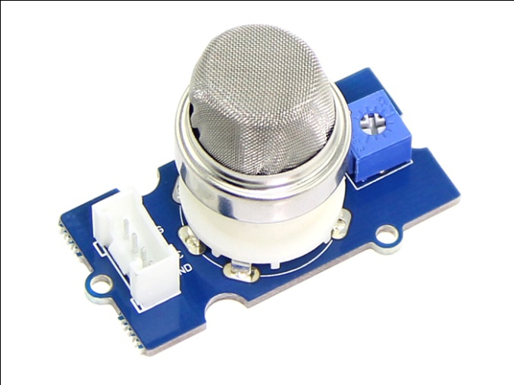

**GAS SENSOR**

**PRESSURE SENSOR**

A device is a pressure sensor that detects pressure and transforms it into an analogue electric signal whose strength is dependent upon the applied pressure. They are also known as pressure transducers because they convert pressure into an electrical signal. A pressure sensor is a device that detects pressure and transforms it into an analogue electric signal whose strength is dependent upon the applied pressure. Other parameters like fluid/gas flow, speed, and altitude can also be measured using pressure sensors. They are also intended to measure dynamically to record extremely quick pressure changes. Pressure is measured by a pressure sensor, usually for gases or liquids. The force necessary to prevent a fluid from expanding is expressed as pressure, which is typically expressed in terms of force per unit area. A pressure sensor typically performs the function of a transducer by producing a signal in response to the applied pressure. The technology, design, performance, suitability for particular applications, and cost of pressure sensors can vary greatly. Pressure sensors that are intended to measure dynamically to record extremely quick changes in pressure. They are utilized to gauge the combustion pressure in a gas turbine or an engine cylinder. Typically, quartz and other piezoelectric materials are used to make these sensors.

**FEATURES**

* Operating voltage : 5v
* Output: analog (0-5v)
* Temperature Compensated from Over -40° to +125°C
* 2.5% Maximum Errors Over 0° to 85°CThermoplastic (PPS) Surface Mount Package

**APPLICATIONS**

* Touch Screen Device
* Bio Medical Equipment
* Aviation
* Marine industry

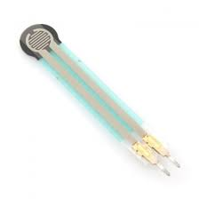

**PRESSURE SENSOR**

**GPS MODULE**

The US government owns and runs the Global Positioning System (GPS), formerly known as Navstar GPS. It is a satellite-based radio navigation system. Any place on or close to the Earth with an unobstructed line of sight to four or more GPS satellites can receive geolocation and time information from the global positioning System.

Although these technologies can enhance the usefulness of the GPS positioning data, the GPS system does not require the user to transmit any data and does not require any telephonic or internet reception. The GPS system gives users in the military, civil, and commercial sectors around the world essential location capabilities. The system, which was created, maintained, and made available without charge by the US government, can be used by anybody with a GPS receiver.

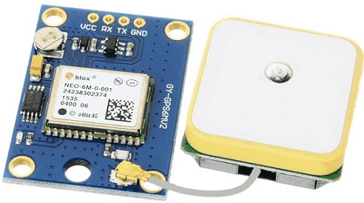

In any weather, the Global Positioning System (GPS), a network of global navigation satellites, provides location and timing data. The GPS operates without the need for any phone or internet reception, despite the fact that these technologies might increase the GPS positioning data's usefulness. Earth receives signal information from GPS satellites. The GPS receiver gathers this signal data in order to determine the user's precise location.

Time and the known placements of specialized satellites serve as the foundation for the GPS concept. Real-time position and timing information is transmitted by GPS satellites. In order to compute the receiver's precise position and its departure from actual time, a GPS receiver continuously scans for satellites and solves equations. Four satellites must constantly be visible to the receiver. Every GPS satellite transmits a signal (carrier wave with modulation) that contains a pseudorandom code continually (sequence of ones and zeros). It is sent with a message that also contains the code epoch's time of transmission (TOT), the receiver's knowledge, and the satellite's location at that precise moment

**FEATURES**

* Precision: 5 meters
* Interface
* UART RS232
* Optional T-TL UART
* Supply voltage: 12v DC
* Automatic antenna switching function

**APPLICATIONS**

* GPS trackers detection
* Automated vehicle
* Robotics
* Fleet tracking status

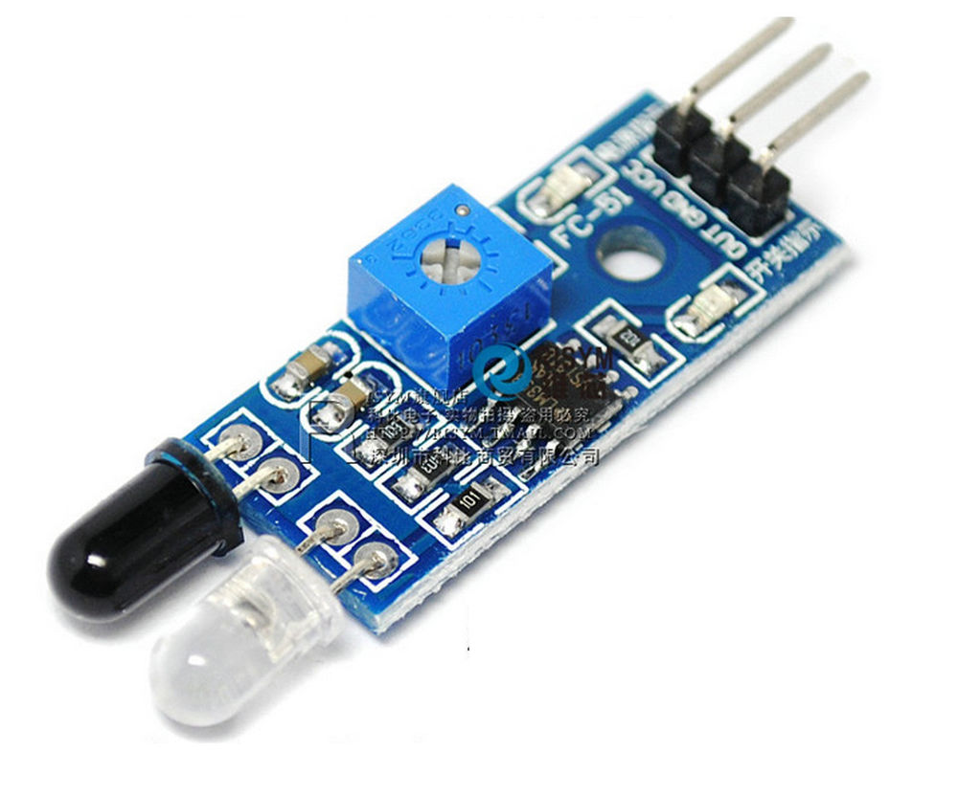

**IR SENSOR**

An electrical device known as a sensor uses infrared light to identify certain components in its environment. An IR sensor can measure an object's heat and detect movement. These kinds of sensors are referred to as passive IR sensors because they only measure infrared light. All objects typically emit some kind of infrared thermal radiation. Despite being undetectable to the human eye, An infrared sensor can pick up these radiations. The detector is an infrared photodiode, which is sensitive to infrared light of the same wavelength as that emitted by the IR LED, and the emitter is an infrared light emitting diode.

**FEATURES**

* Input voltage : 3.3v
* Output : Analog

**APPLICATION**

* Radiation Thermometer
* Flame Monitors
* Moisture Analyzer
* Gas Analyzer

# **Conclusion**

The main goals of this operation were to maintain tabs on the miners who needed help, lower the number of casualties, and give them that help right away. A microcontroller and node Mcu were used to build a wireless sensor network on the miners' helmets. A pressure sensor was fastened to the sensor mote in order to keep track of the user's health. The helmet's microcontroller attempted to send an email or text message. whenever the force experienced by the helmet surpassed the pre-set threshold value, a notice message was sent to its Room Manager via the saved route.